Key Issues

• The find query is taking awfully long time to display the results for the PlaceOrder

collection.

• Your manager has asked you to find the number of total orders available and the number of

orders with the “Delivered” order status.

Approach to Solve

• Use Nosqlclient application to create index based on “orderId” of PlaceOrder collection.

• Find the count of all the documents in order collection and find the count of documents with

orderStatus “Delivered”

Solution:

1. Create DB



1. Create collection PlaceOrder



1. Insert data into a collection
2. Create Index with orderId

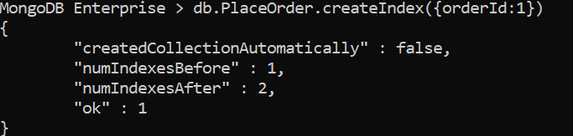

1. 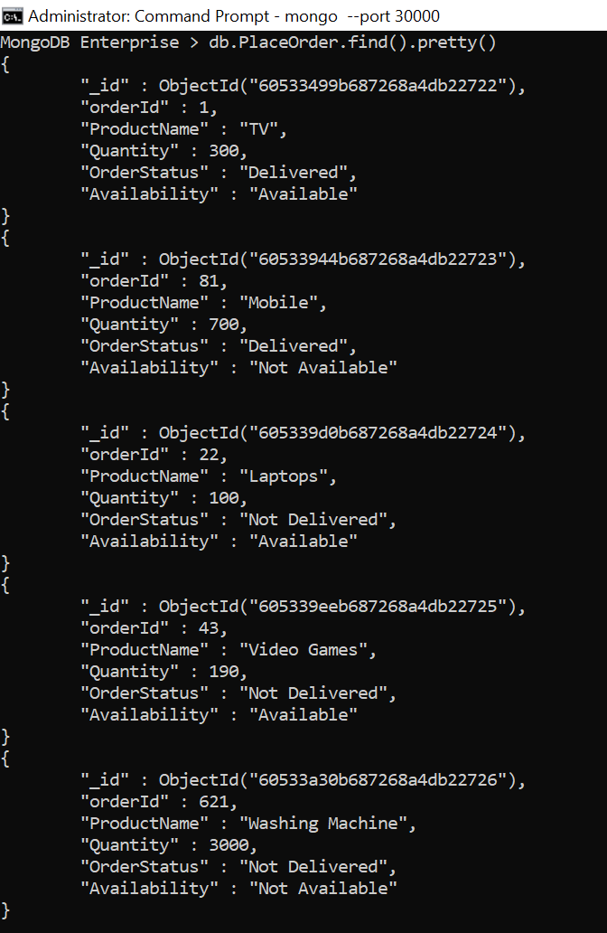Display all product information or DB
2. Show Indexes using getIndexes()

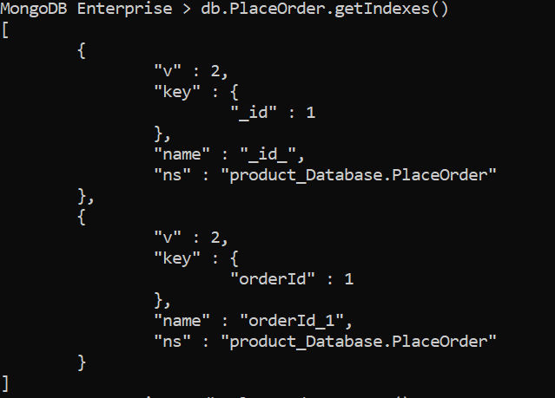

1. 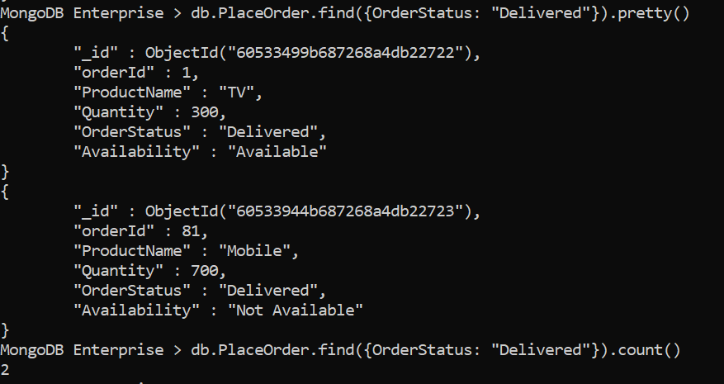Display all product information which OrderStatus is Delivered with count.
2. Display all the product which are available with count

